1. Using YOLO we can get the centre pixel coordinate of leaves, we do this on a single image say right one.
2. We take the left and right image and using openCV and python we can get a disparity map.

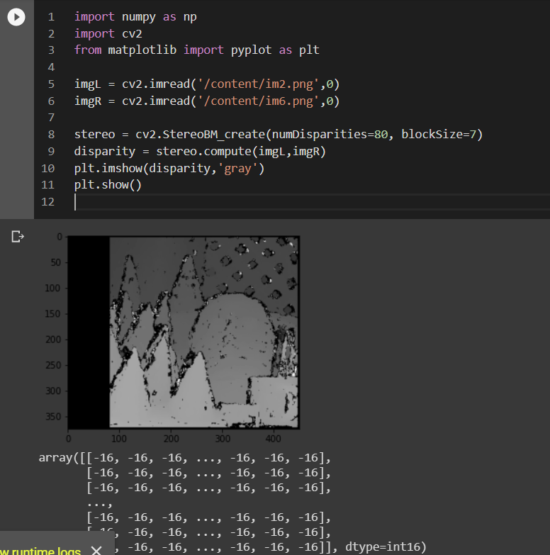

1. This gives us approx. pixel shift value say “d” from it.
2. Now we use the following geometry to calculate the distance, given we know how far are the centres of the right and left cameras say “L” and the angle of vision say ”theta” or focal length “f”

( some details <https://www.intechopen.com/books/coding-theory/efficient-depth-estimation-using-sparse-stereo-vision-with-other-perception-techniques>)

1. The formula used is Z = L\*f/d